KARIBU CHAKAMA
International projects for the development of rural and poor areas
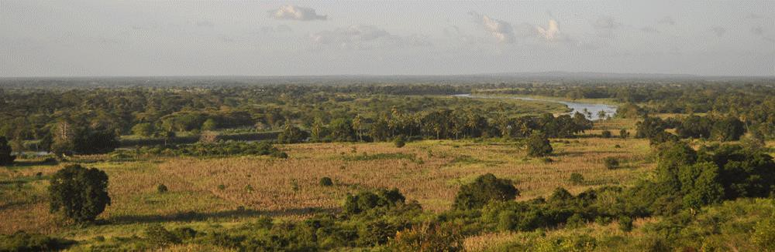

PROTOTYPE MODEL

WHY THE CHARITY PROJECT
PREFACE

This project stems from the deepest and most beautiful human feeling, the love for the neighbor.
Jesus said, "Love your neighbor like you love yourself" and this project totally respects these words
The Karibu has identified, therefore, its neighbour in all people who do not have the means to hope for a better future or, simply, all people who do not have the necessary care.
Here is the desire to offer children free education and adults a continuous, profitable job.
Here is also the desire to take care of the poor, sick and lonely elderly and to care for all women ready to give birth to a new creature.
In this way our project began, ten years ago.

WHY KIBORA

Because of the inscrutable mysteries that fascinate our life, one day I found myself pushed there from my destiny.
Certainly by God's will.
And that day I did not ask the people about their poverty, but I came spontaneously to tell them only
"Ok, Where do we start?"
I did not waste time to understand the reasons of that poverty and solitude in the middle of the savannah.
The reality was as obvious as the answers I would have received.
That’s why I have never explained the reasons why they are poor.
Today, we are a public school with official certification of Ministry of Education of Kenya that offers free education to 431 children aged 4 to 12.
Do not ask me why all this ardor in to accomplish this project.
I can only say, "We are loving our neighbors like we love ourselves"
Hoping that the children of today will collect this heritage in the next future.
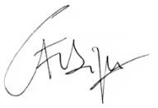
popi fabrizio

CHAKAMA AREA GENERAL PROJECT

PROJECTS DONE

KIBORA PRIMARY SCHOOL  PRIMARY STD -1-2-3-4-5-6-7  PRE-PRYMARY PP1-2 | DIFFERENT PROJECTS:  LIBRARY  CHAPPEL  WATER SUPPLY  POWER SUPPLY | OPPORTUNITIES  1. SHAMBA 16 Acres  2. (Vegetables and Fruit)  BEE-KEEPING

PROJECTS TO BE FINANCED

PRIMARY STANDARD 8  BUILDING  FURNISHING  EQUIPMENT  STAFF | TECHNICAL SCHOOL OF WORKS  BUILDING  FURNISHING  EQUIPMENT  STAFF | TILAPIA  WATER CONTROL EQUIPMENT  LAKE
COMMUNITY HALL  Main Building  Restaurant  Offices  First Aid  Stage Store | 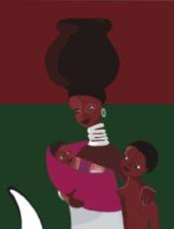 | NEVER ENDING STORY HOUSE  (NESH)  BUILDING  FURNISHING  EQUIPMENT  STAFF

PRIMARY STANDARD 8

- CONSTRUCTION BUILDING
- FURNISHINGS
- TEACHERS

The building consists of a building consisting of:

- 1 room of 56 sqm the one to be used for classrooms

The furnishings consist of:
- 1 Teacher DESKS
- 40 Benches
- 1 wall panels
- 2 multifunctional cabinets
- 2 chairs
- 1 large meeting table

TEACHERS:
TEACHERS 1

TECHNICAL SCHOOL OF WORKS

Chuo Cha Ufundi

For the experience, made in Chakama in these 10 years, I realized that for most young people living in rural areas it is practically impossible to start university studies. The main problem is the economic factor.
As a result, they find themselves educated at 18 but without the knowledge necessary to get a job.
Therefore, we have decided to include in our educational project the creation of a school which, immediately after the Primary, offers the students technical lessons to learn seriously to work in the various commercial and industrial sectors and enter the world of work.
We will start with four courses, the most useful and practical ones:
  - Mason-painter
  - Plumber
  - Electrician
  - Farmer

while to follow we will start:

  - Computer Technology
  - Mechanics / Driver
  - Taylor
  - Restaurant and Hotel services
  - Carpenter

The school is dedicated to facilitate young learning and getting the job they prefer as soon as they learn.
The theory will be teached from Monday to Thursday while Friday and Saturday the students will be assistant Example:
Those who choose NURSE will be hospital assistant on Friday and Saturday while those who choose TAILOR will be a tailor's assistant and so on, the same for all other courses.

Karibu will provide the structure for theoretical courses in Kiborafarm Center and will offer free accommodation for totally 24 students. They are only requested to pay boarding materials, accessories and food. Karibu will provide also the various agreements whit each partner involved for practice.
At the end of the courses students will receive our certification with special note of all teachers and partners.
The duration of the courses varies according to the courses
All courses are continuous with one month break between the end and the beginning of the new course.
We will open one SERVICES OFFICES in MALINDI to give job to all our student

TILAPIA PROJECT

It consists in the purchase of a land already identified, to build a small lake using the waters of the GALANA River, both in and out.
Tilapia has a high rhythm of both reproduction and egg quantity. This will ensure enough food for the community and trade with all the neighboring towns to Malindi. Also shrimp and small river fish.
The system consists of:
    - Pipeline for running from river to lake and vice versa with control trap for drainage and water cleaning
    - Pump to facilitate the flow of water from the river to the lake
    - Small cabin for pump control and operation

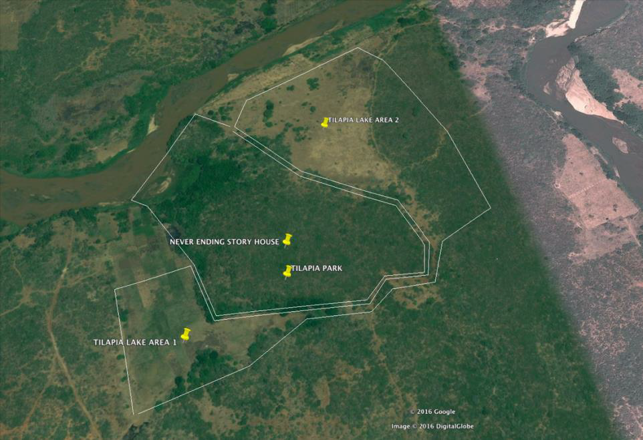

NEVER ENDING STORY HOUSE
Maternity and elderly care project

The final act of the project that starts with childhood and closes with the assistance of the elderly.
The elderly, alone, poor and sick. In summary, a Resting House where they will be assisted with love and attention until their death. In particular, it will be of assistance to all terminal patients trying to make their last years of life less difficult.
But to give the very meaning of the endless cycle of our lives, an area will be reserved for those who will be carefully assisted in the special, unique and wonderful moment of childbirth.
The property is made up of many small, two-person cottages, scattered in the small grove close to the lake and all connected to the Direction and Reception Center.
All this is free and subsidized by KARIBU ONLUS with the support of any donors.
The initial cottages will be 8 to accommodate 16 elderly and will reach 24 in the next 5 years

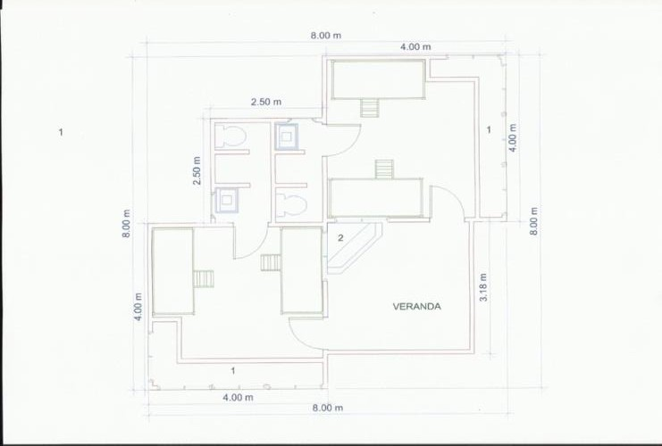

Example of cottages for two people

COMMUNITY HALL
AGORA has always been the center of the polis, the city, a living nucleus.
The sacred place for religious functions, the political site, the place of the encounter, the place where a community recognizes itself, the place where a community grows, with its rites, its laws, with its continuous live. And it governs.
KIBORA is no exception, this is why the need for this vital structure.
The KIBORA Agora will be in the shape of a shell and will be called KUBWA KAURI, the Great Shell, a sort of maternal womb for all its present and future children, to any ethnicity they belong to.

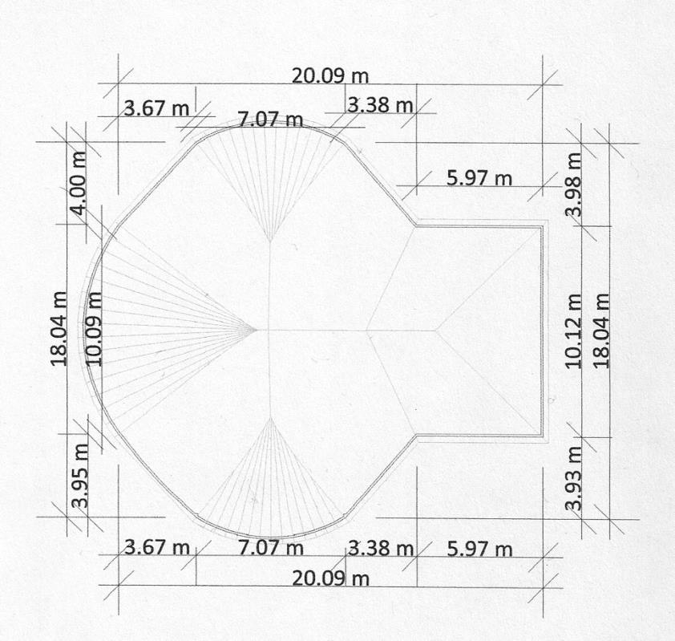
The structure will be underground for 2.00 meters, surrounded by staircases and a large stage will be built at the southern end.
The cover will be supported by large wooden beams of casuarina specially treated and made entirely in MAKUTI, the characteristic roof of Kenya

KARIBU ONLUS BUSINESS PLAN

2020 | 2021 | 2022

- PRIMARY STD 8  - LIBRARY  - CHAPPEL | - TECHNICAL SCHOOL  - TILAPIA LAKE&PARK | - NESH Hospital  - COMMUNITY HALL
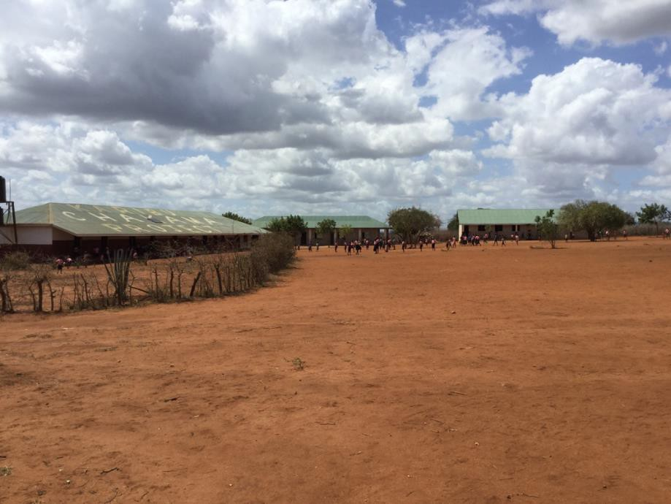

OUR FIRST BIG TARGET

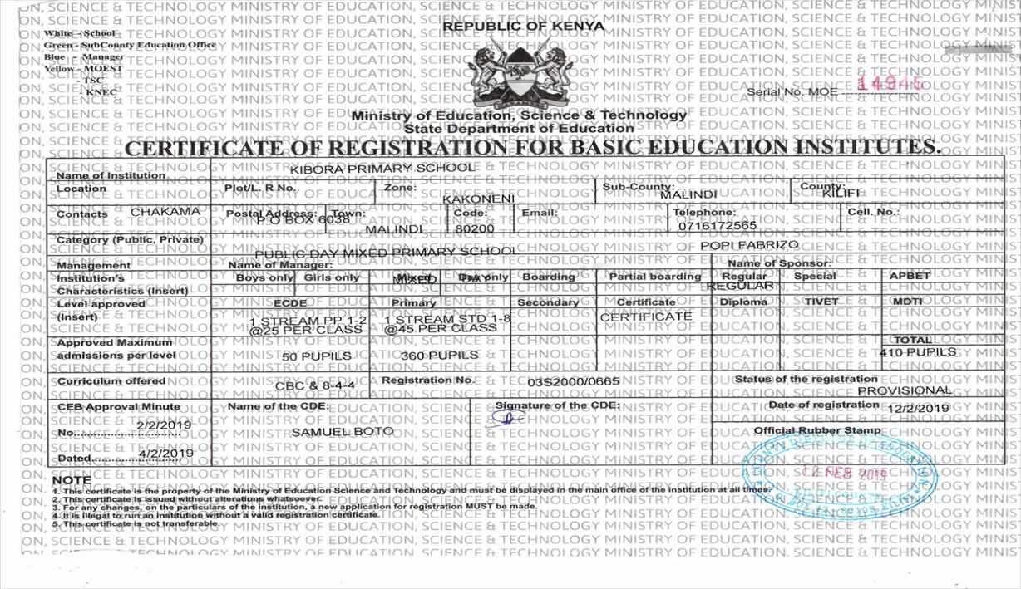

The most important thing you’ll never learn is to love and be loved in return

PROTOTYPE CBO CONSTITUTION

COMMUNITIES AND CBO

A community is the set of people who speak the same language, live in the same place and entrust to an organized CBO for the social management of their lives.
For example, every democratic nation in the world is more or less organized at all population levels:
The nation, the regions, the municipalities, the villages, the city committee.
Each of these bodies must have its own administration. Of course everyone must comply with national laws but then laws and administrations must be adapted according to territorial and environmental needs.
For example, those who live in the mountains have different life needs than those who live in the countryside, those who live by the sea and finally those who live in large cities.
For all of them, however, there is a national governing body that guides the inhabitants by respecting the laws of the national government. But everyone has to deal with his population and that is why he includes the CBO.
The Government cannot always meet the needs of all citizens and this makes certain areas with many citizens isolated and abandoned to themselves.
Poverty is the great unease of these areas and their population
The CBO therefore affirms the filter of the Public Administration and the local population and has the aim of making decisions together with the representative of the Government to help the population and get out of poverty.

CBO CHAKAMA

1-The CBO CHAKAMA is the voice of the people who speak to the government.
2-The CBO meets once a month to discuss the problems, requests of one or more citizens, the needs and urgencies of the community.
3-The CBO meets with the population 2 times a year to pay the ratio of all the work done, things done, to do, the money spent, the money collected.
4-The CBO will have a bank account and each citizen will have free access to verify the regularity.
5- The CBO will always show the monthly reports on the bulletin board of its headquarters.
6-The CBO will be its headquarters, COMMUNITY HALL. It will be provided by Karibu Onlus, at its own expense, by 2020.
7-The CBO must deal with the life of the population, therefore in prevalence of
Work,School,Health,Environment
8-The CBO must be made up of members of all social strata and ages.
* Youth 5 (20/30 years)
* Adults 8 (31/60)
* Seniors 4 (Over 60 years)
9-Each member of the CBO receives a salary of Ksh 500 for each monthly meeting and Ksh 1000 on the occasion of the two annual reports.
10-To be protected by the CBO the population must register with the CBO and must pay a monthly sum of Ksh 500 for the expenses incurred by the CBO.
11-The CBO must renew its members every two years and the registered population will choose.
12-The CBO must:
* Provide jobs, inside and outside your jurisdiction.
* Manage schools in agreement with Principals, Vice Principals and Relatives Committee.
* Improve healthcare facilities
* Improve public structures (roads-water-power-buildings)
* Define the realization of new projects with Karibu Onlus.
13-The first members of the CBO will be chosen by the Karibu Onlus in agreement with ministerial representatives.

14-Instead, it will be the population enrolled in the CBO, when it reaches 500 members, that will choose its new representatives.
15-Each newly elected CBO member must swear loyalty, honesty, transparency and seriousness of his duties before the population and his oath will be well photographed and recorded in audio
16-Any member, none excluded, who will behave contrary to his oath foreseen in article 15, will be judged by the population in the first of the two half-yearly meetings following his absence.
16-The member, depending on degree of seriousness of the crime committed, will be dismissed and never more able to be re-elected or reported to the government judicial authority
17- The CBO is made up as follows:
* President
* Vice president
* Treasurer
* Secretary
* Sports Department 1
* Health Department 3
* Labor Department 3
* Schools Department 3
* Public Structures Department 3
18-In votes among the members of the CBO relating to any type of choice, the President is always the last to vote.
19-Each member must participate in all CBO meetings. He can be missing up to twice during a year with incontrovertible written justification but he cannot be missing at the two meetings with the population. Missing a meeting with the population imposes a recall letter from the President and after the 3rd recall the member will be separated from the CBO and replaced with an alternate member chosen by the President. This alternate will remain in office until the first subsequent six-monthly meeting.
20-The CBO will always take care of registered citizens who are poor and sick.
Karibu will take care of all the necessary needs after carefully reading the situation.
21-Citizens enrolled in the CBO regulations immediately obtain:
* Free school for each child
* Medical assistance for the elderly
All other benefits will come year by year.

22- The plans planned for the future are all in collaboration with the Karibu Onlus:
* Fishing point: All members ordered free right to 1 kg of fish per month.
* Technical Insitute: provide free education to learn a job in a short time.
* Employment agency in Malindi: find work for students attending the Technical Institute
* Free water: each member will be entitled to a certain free monthly quantity of clean water.
* NESH: the structure that will host women giving birth and lonely elderly people, poor and sick.
* Acquisition of land: to open new crops, offer new job opportunities and build new structures.
* Purchase of vehicles is intended for school use, commercial use towards Malindi, medical services for medical emergencies. Members will always travel for free.
* Construction of a sports center in association with an Italian sports club.
* Playgrounds and equipment

Obviously all this will not happen in a single day but it is like a large mango tree. It will be a sprout at the beginning, it will bring wonderful fruits that we all enjoy, always!
The CBO CHAKAMA must be the example for all the other rural communities in poor areas scattered in Kenya.

In this way the first men hanging on the earth grew, evolved and built the great civilization of today.

